**Lesson Notes**

1. What is the main purpose of an Operating System?

Simpler/more efficient application programs

Consistent user experience

Allow multiple applications running at same time

1. What is the difference between Operating System Software and Use Application Software?

Hardware independence

User interface

Resource allocation

1. What is the difference between Operating System Software and Computer Hardware?

(Hardware is touchable, OS is intangible. Software controls all PC operations.)

1. What are the main parts of an Operating System?

Graphical user interface

Systems calls

Device drivers

I/O Manager

1. What are some popular operating systems?

Windows

iOS

Android

**Reference Diagram**

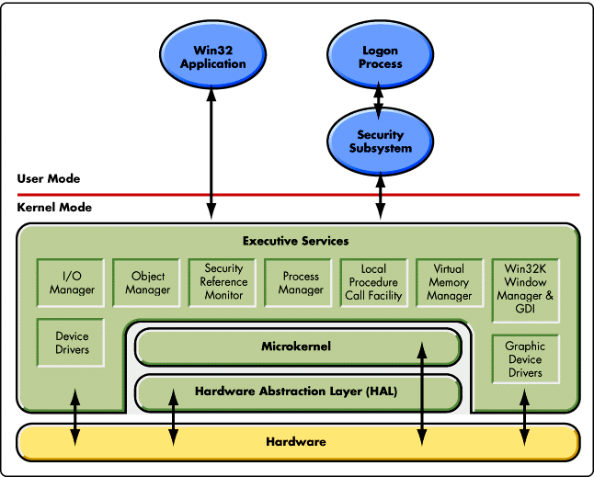

**Student Questions**

1. What is a device driver?
   1. Provide a brief summary

(More commonly known as a driver, a device driver is a group of files that enable one or more hardware devices to communicate with the computer's operating system.

* 1. List some devices that require a device driver.
* printer drivers.
* Display drivers.
* ROM drivers.
* BIOS driver.
* USB drivers.
* VGA drivers.
* Sound card Driver.
* motherboard drivers
  1. Provide a label on the reference diagram for the location of a device driver for your graphics card.
  2. Provide a label on the reference diagram for the location of a device driver for a locally attached printer.

1. What is a DLL?
   1. Provide a brief summary

(A DLL is a library that contains code and data that can be used by more than one program at the same time.)

* 1. Explain how DLLs are related to user application programs

(Lets you open multiple tabs at once or windows.)

* 1. Provide a label on the reference diagram for the location of a DLL

1. What is a windows manager?
   1. Provide a brief summary

(A Window Manager is the program responsible for coordinating all the windows on the screen.)

* 1. Explain how a windows manager is related to user application programs

(You can place the window anywhere on the screen and you can adjust the size of the window.)

* 1. Provide a label on the reference diagram for the location of a DLL

1. What is the windows task manager?
   1. Provide a brief summary

(The Windows Task Manager is a powerful tool packed with useful information, from your system’s overall resource usage to detailed statistics about each process.)

* 1. List and explain four (4) types of system information provided by the task manager

(Memory footprint-The amount of memory (RAM) software uses when running, CPU- The CPU usage of the process, displayed as a percentage of your total available CPU resources, Network-The Networking tab shows statistics relating to each of the network adapters present in the computer. Process ID-The Networking tab shows statistics relating to each of the network adapters present in the computer.)

* 1. Provide a label on the reference diagram for the operating system components related to each type of information.